August 2024 Newsletter

**Mayor:**

Roy Schulz

**Council:**

Shelly Ausmus

Lydia Fletcher

Michael Hale

Margie Jaeger

Pete Martin

Amanda Prince

Dave Tysz

**Clerk/Treasurer:**

Eliza Evans-Teague

**Deputy Clerk:**

DonNell Ellsworth

**Maintenance/**

**Animal Control:**

Jessica May Johnson

Steven Thomas

Kevin Turnbough

**Code Enforcement Officer:**

Mike Bogenreif

509-828-2144

tekoacodeenforcement@outlook.com

**Building Inspector:**

Steve Haxton

509-981-2157

**Office Hours:**

8:00 A.M. to

4:00 P.M.

**Council Meetings:**

First and Third Monday

6:00 P.M.

Tekoa City Hall Council Chambers

**Phone:**

509-284-3861

**Fax:**

509-284-3590

**Email:**

tekoaclerk

@gmail.com

**Website:**

www.tekoawa.com

|  |  |
| --- | --- |
| August 2 - Chamber of Commerce  7:30 A.M. – Éclair’s  August 5 – City Council Meeting  6:00 P.M. – City Hall  August 6 – Tekoa EMS & EMT Training  6:30 P.M. – Ambulance Barn  August 6 – Whitman Co. Hosp. Dist.  6:30 P.M. – City Hall | August 8 - Empire Theatre Board  5:30 P.M. - Empire Theatre  August 19 – City Council Meeting  6:00 P.M. – City Hall  August 20 – Tekoa Parks & Rec Meeting  6:00 P.M. – City Hall  August 28 – Tekoa Ambulance Board Mtg.  6:30 P.M. – Ambulance Barn |

3



**The City of Tekoa will have our council meeting in the Tekoa City Hall council chambers on Monday, August 5, and 19, at 6:00 P.M. You may join in person.**

*Message from the Mayor—*

Hello everyone, I hope you are enjoying your summer. As I write this, we have just experienced quite a run of hot weather, and I hope we are about to see a break in the temperatures. I will try to be brief this month…We'll see, I guess.

There seems to be some confusion about the recycling container at Tekoa City Hall. The dumpster will take broken down cardboard, any clean plastic marked**RECYCLABLE**, # 1-7, without lids, any clean paper, newspaper, magazines, and clean tin and aluminum cans. **PLEASE, NO GARBAGE**. All of our staff continue the need to police and remove unwanted items from inside the dumpster. The burn pile by the city hall is closed for the time being because of the citywide burn ban. The tentative reopening date is September 15. We will have more information in the September newsletter.

The council continues to look into the feasibility of allowing container storage units in areas of the city. Keep sending your thoughts either to the office or council members. Also, if you want to bring in **any storage shed larger than 120 square feet, you will need a permit**.

You may have noticed there has been some extensive trimming and pruning on a few properties around town where things needed some help. The Upper Columbia Academy, with permission from the owners, brought in a crew to volunteer to clean up a few properties where they could. This is where it gets complicated. UCA wishes to come back and give us more volunteer hours. What we need from everyone is to identify and, in a sense, nominate properties where these crews, under supervision, would clean, prune, trim, weed, wash, scrape paint, paint, sweep, and maybe even rebuild. The owner's permission is imperative, and the scope of the work will have to be worked out, but I believe this could really have a positive effect on our town. If you have any thoughts, feel free to contact city hall. Thank you for your patience and we will talk in a month.

***"Knowledge is knowing it's a one-way street; wisdom is looking both***

***ways anyway."  Albert Einstein***



Roy

Tekoa Food Pantry

Tekoa Food Pantry will distribute commodities on August 22, from 8-11 A.M. Keep an eye on Facebook and the reader board for the free fresh produce handouts in August.

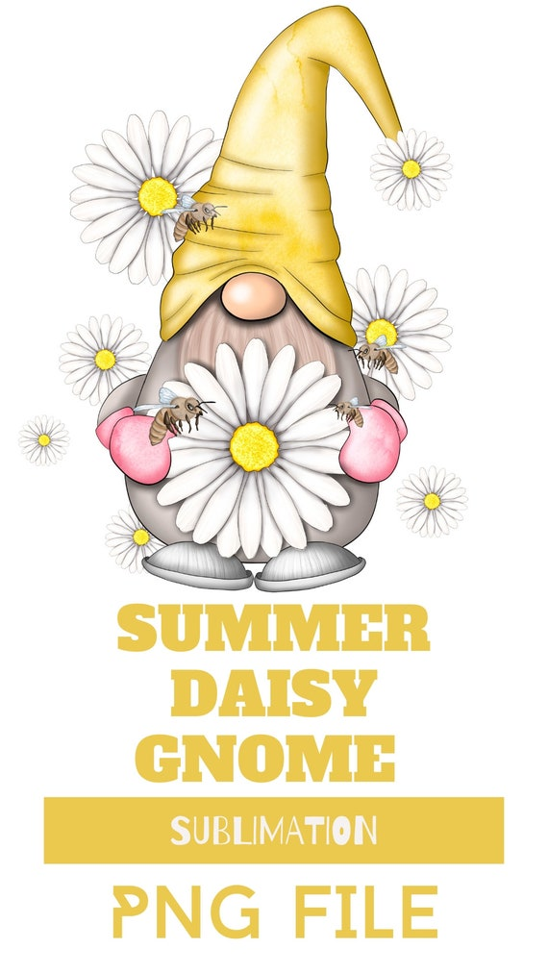



**Tekoa Library Happenings**

The library is looking forward to seeing you at **the National Night Out on August 6th**. With the help of the Innovia Foundation, the library was able to help sponsor the food, and we’ll be there with a game to help you cool off. **While we’ll be at National Night Out, remember that the library and all Whitman County Libraries are closed the entire week of August 5 for our annual maintenance week.** Summer Reading is in full swing and wraps up with a showing of **Pixar’s movie UP on August 21, 6:00 P.M., at the theatre**. Thank you, Tekoa Empire Theatre and Healthy Tekoa Coalition, for co-sponsoring this free family event. Be sure to stop by the library by August 21 to turn in your punch card and collect prizes. Finally, free Spanish classes are happening on August 1, 15, 22, and 29 at 1:00 P.M. You don’t have to be at all of them to attend. *For info about all our programs, follow the Tekoa Library on FB or visit our website: www.*[*whitcolib.org*](http://whitcolib.org/)*. Phone number:  509-284-5657.*

Empire Theatre

On Wednesday, August 21, the library, along with Healthy Tekoa will be sponsoring the showing of the movie **UP**, Admission is **FREE,** and concessions will be available for purchase at $2 each.

Tekoa City Hall

We will be completing a scrub seal project that was delayed from last summer. This will be paid for with a grant from the Washington Transportation Improvement Board. This project is to be started and completed in the third week of August. The roads that will be affected are North Washington from the Sacred Heart Catholic Church to Crosby Street (by the LED sign), Ramsey Street from Railroad to Main, and Connell from Crosby to the ball field. There could be up to a two-hour window that no traffic will be allowed on these roads. During the prep phase and completion phase all vehicles, RVs, campers, or anything else parked along the road will need to be removed before the work is started and not returned until the project is completed. Thank you for your understanding and patience while we improve our streets.



**August 3** is the **Tekoa Community Yard Sale Day**. If you would like your yard sale on the map, please sign up at the Tekoa Market. Maps of all signed-up yard sales with be handed out at the Tekoa Market on Saturday, August 3. This event is sponsored by the Tekoa Chamber of Commerce.

**HEALTHY TEKOA**

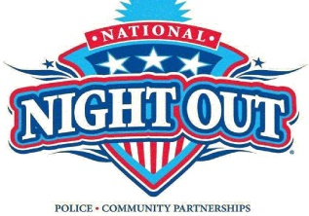

It was wonderful seeing our families and friends out at Slippery Gulch! Mark your calendars for the National Night Out on Tuesday, August 6, starting at 6 P.M., at the softball field (6-8 P.M.) to recognize and support our local first responders. We partnered with the Tekoa Library and Banner Bank to bring food and activities for families and neighbors.

Keep Talking Tekoa! Fill your child’s life with positive experiences showing they are supported and protected. Help them become resilient with the ability to talk to family about feelings, feel safe & protected by an adult at home, and participate in community traditions.

Learn more at <https://healthytekoa.org/parentscorner> Enjoy your summer. Our next meeting is Tuesday, September 10, at 9 A.M. Email jolson@tekoasd.org for more info.

